1. Program List Directory file

Script :

*//requiring path and fs modules*

*const* path = require('path');

*const* fs = require('fs');

*//joining path of directory*

*const* directoryPath = path.join(__dirname, '');

*//passsing directoryPath and callback function*

fs.readdir(directoryPath, *function*(*err*, *files*) {

*//handling error*

    if (err) {

        return console.log('Unable to scan directory: ' + err);

    }

*//listing all files using forEach*

    files.forEach(*function*(*file*) {

*// Do whatever you want to do with the file*

        console.log(file);

    });

});

Prepare :

Install FS Framework : npm i fs

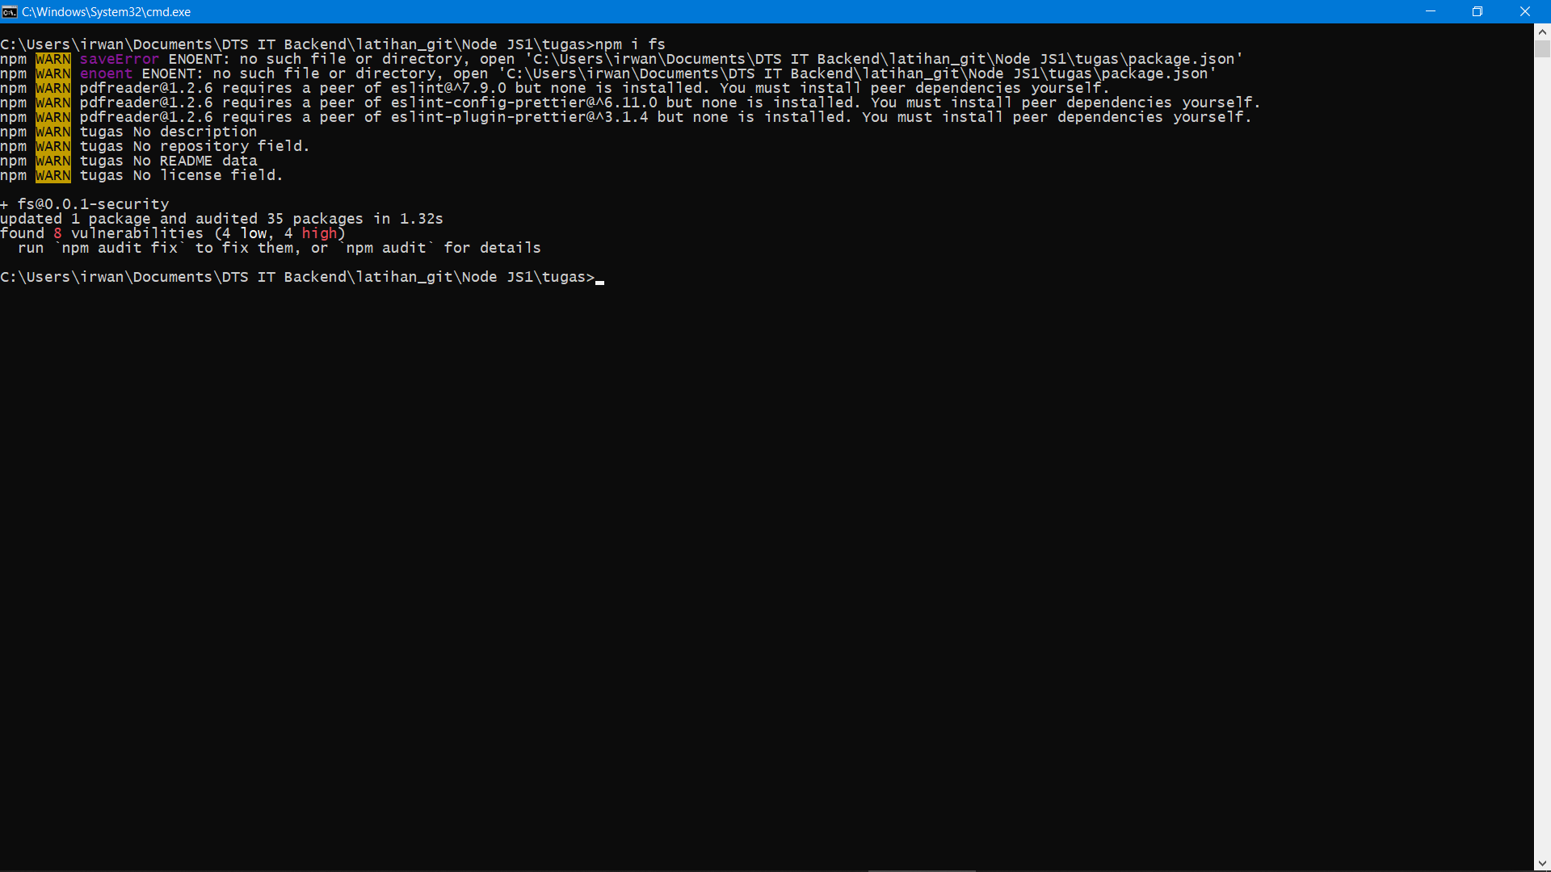

Install Path Framework : npm i path

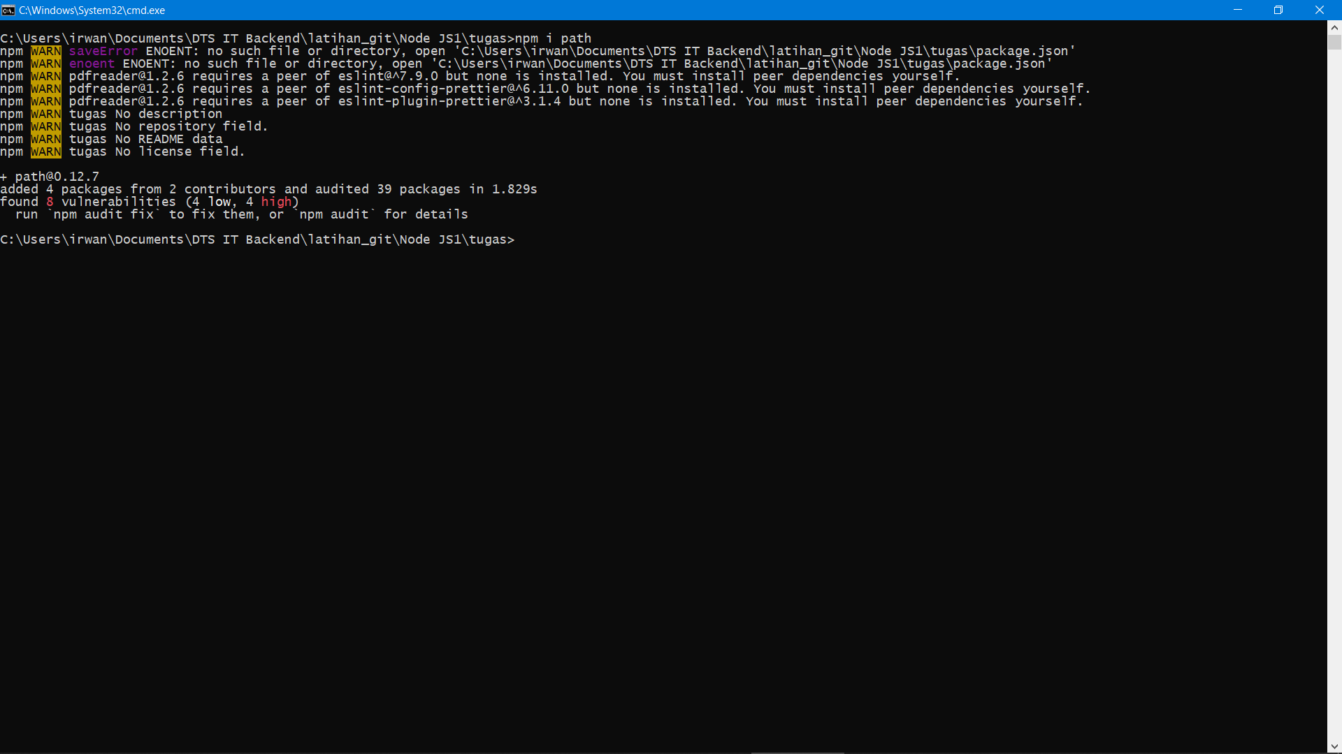

Execute :

Open directory file js.

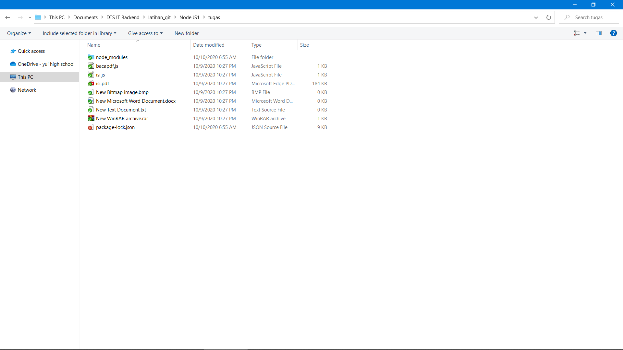

Change Address bar and type Cmd then press Enter

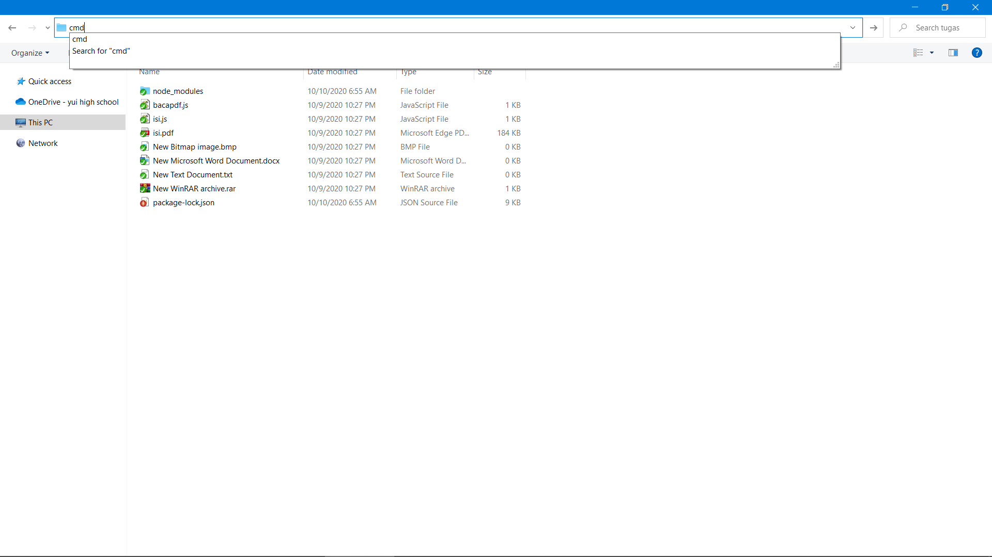

Command Line with the last path directory will shown.

Type “node isi.js” in command line. Then press Enter and the list directory file will shown.

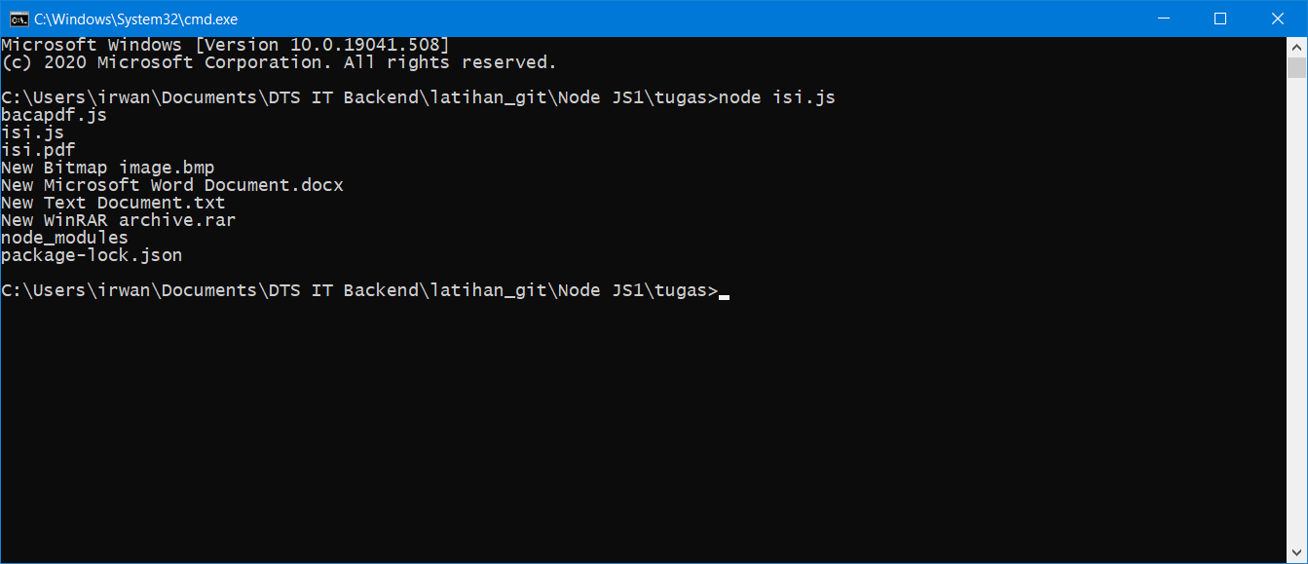

1. Program Read PDF File

Script :

*const* fs = require('fs') *//load file system framework*

*const* pdfparse = require('pdf-parse') *//load pdf parser framework. kita harus menginstall terlebih dahulu ke alamat direktorinya dengan mengetik npm i pdf-parse*

*const* pdffile = fs.readFileSync('isi.pdf') *// membaca file isi.pdf yang ada pada direktori*

*// get the information*

pdfparse(pdffile).then(*function*(*data*) { *// load seluruh properti data pdf isi*

*// number of pages*

    console.log(data.numpages);

*// number of rendered pages*

    console.log(data.numrender);

*// PDF info*

    console.log(data.info);

*// PDF metadata*

    console.log(data.metadata);

*// PDF.js version*

    console.log(data.version);

*// PDF text*

    console.log(data.text);

})

Prepare :

Install FS Framework : *npm i pdf-parse*

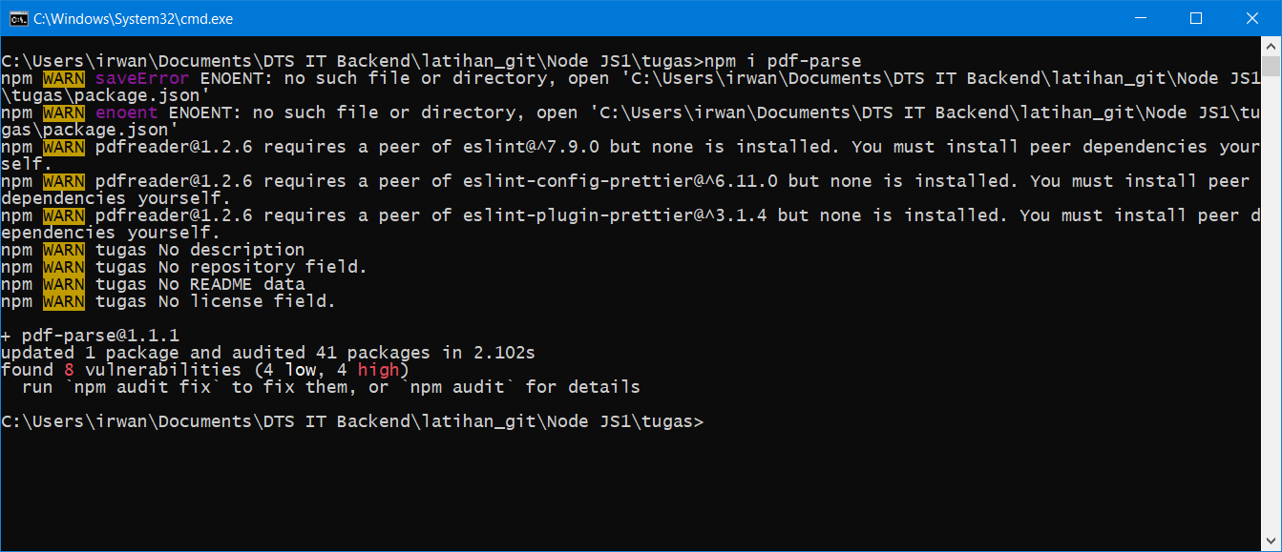

Execute :

Open directory file js.



Change Address bar and type Cmd then press Enter



Command Line with the last path directory will shown.

Type “node bacapdf.js” in command line. Then press Enter and the property of pdf will shown.

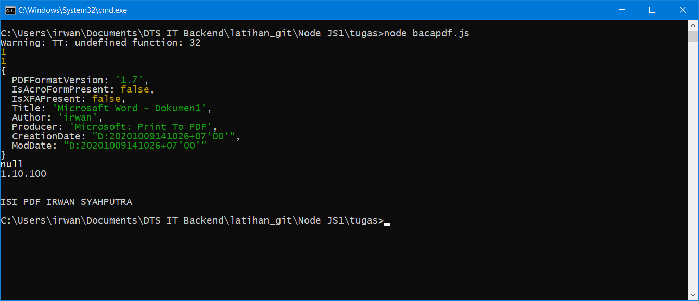

1. Program Post request body and View

Prepare :

Create Directory

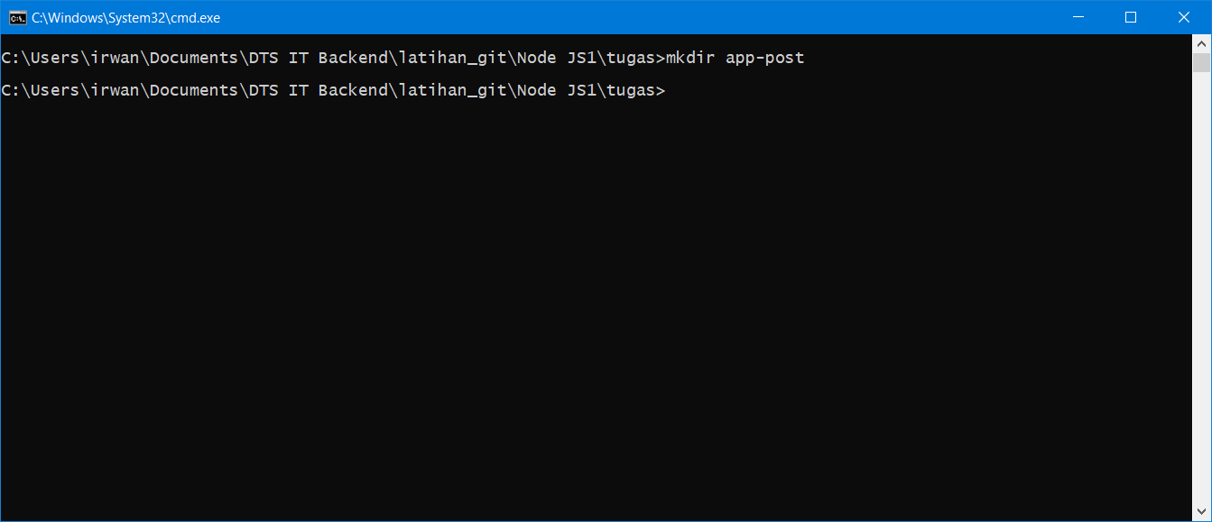

Change to directory that has createn before use command line and type **cd app-post** then press enter. After that. Type npm init.

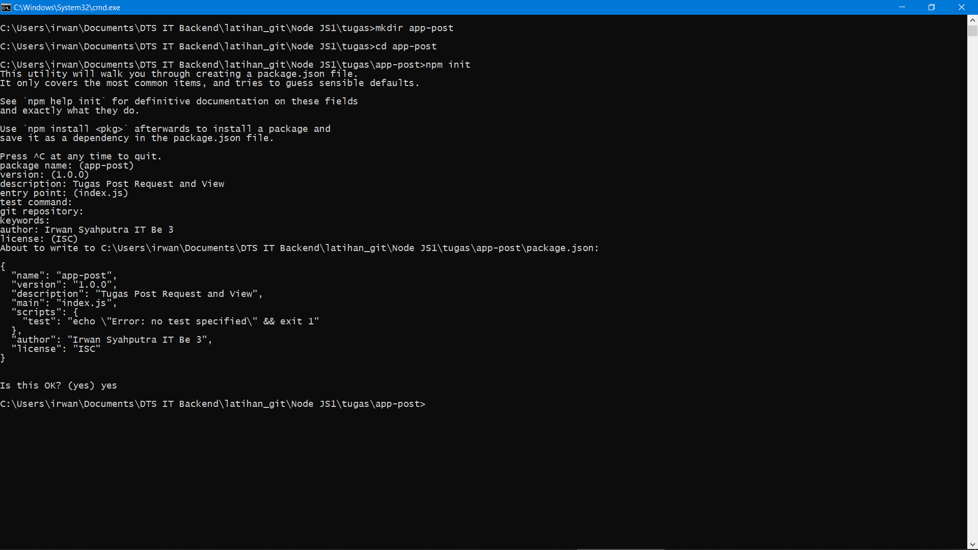

Download <https://getbootstrap.com/> and place the file download on public and extract it.

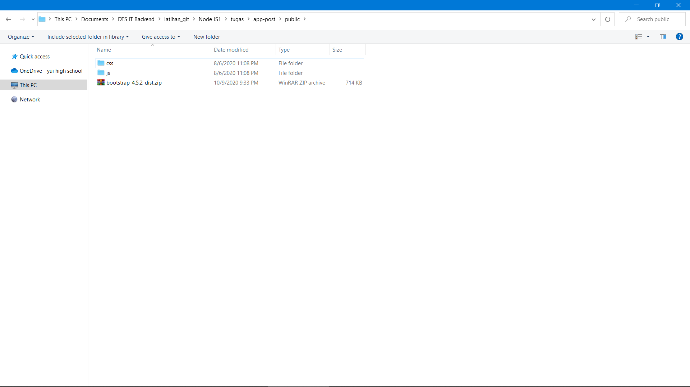

Create file index.hbs and post.hbs on directory views

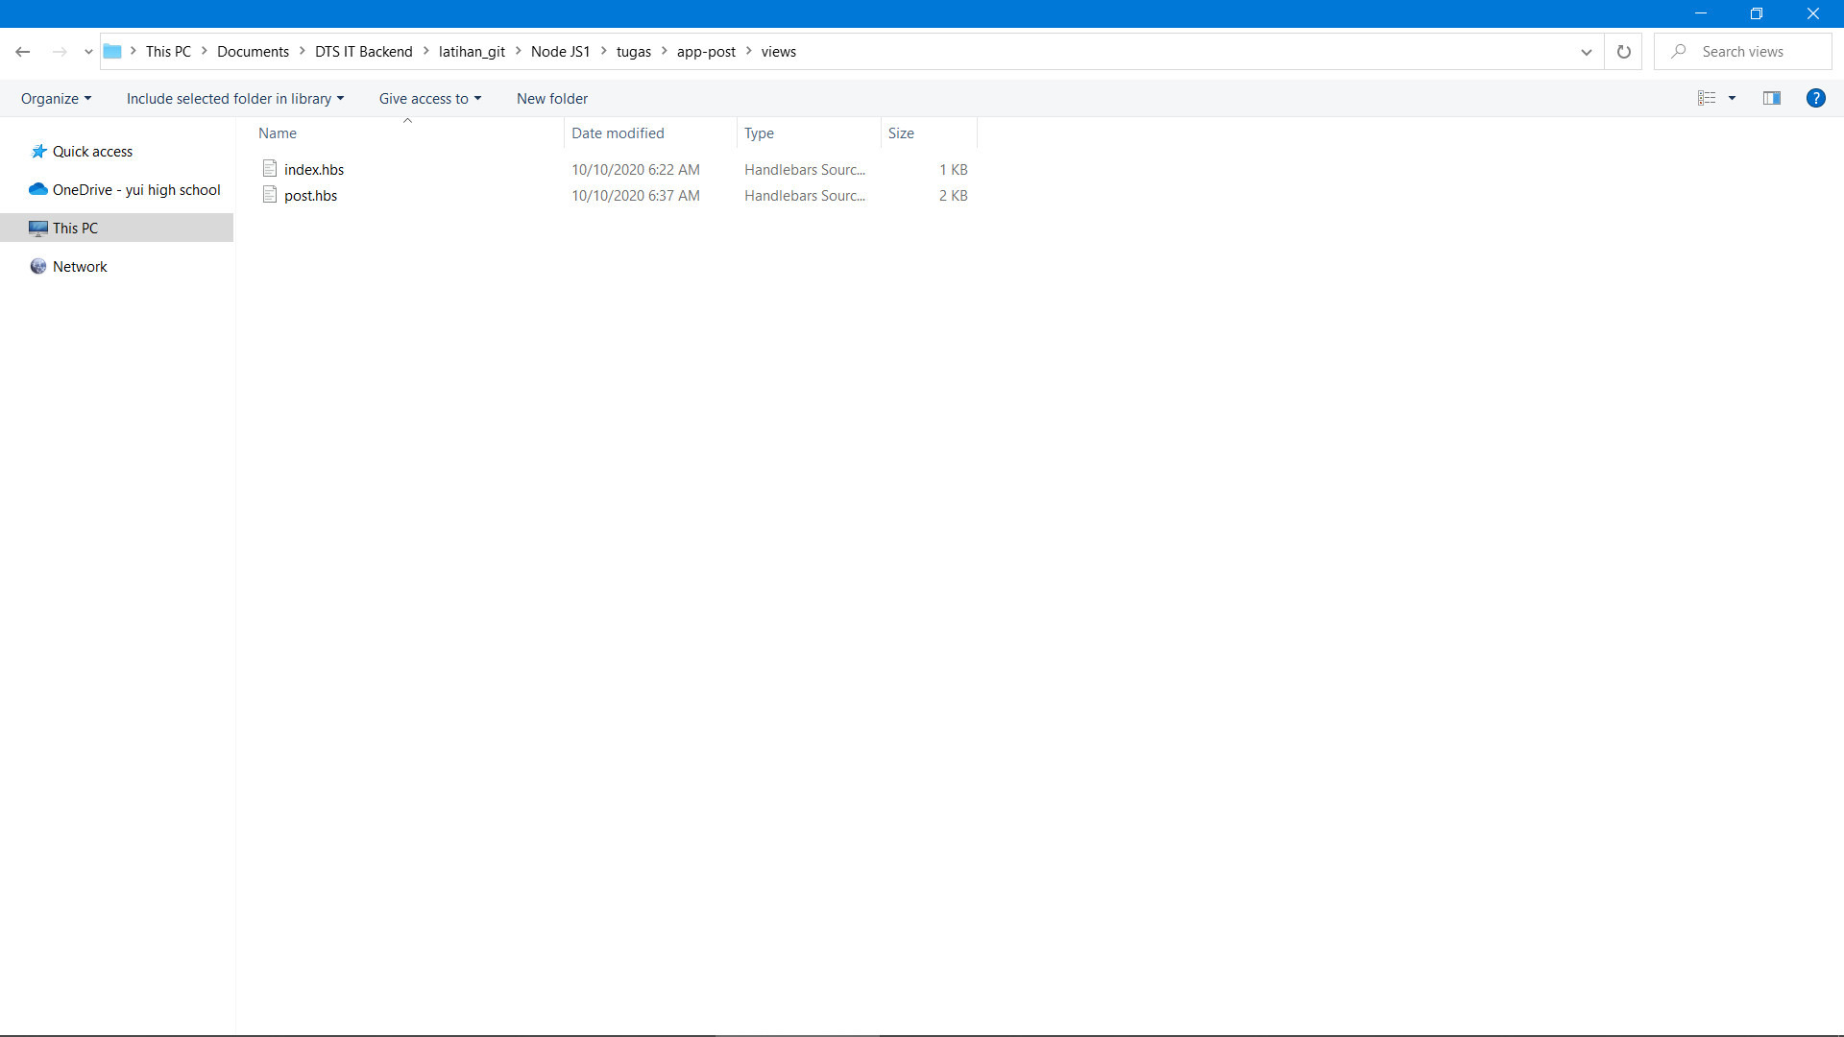

Script indeks.hbs

<!DOCTYPE html>

<html *lang=*"en">

<head>

    <meta *charset=*"utf-8">

    <title>Hello {{ *name* }}</title>

*<!--Load bootstrap.css file-->*

    <link *rel=*"stylesheet" *href=*"css/bootstrap.css" />

</head>

<body>

    <div *class=*"container">

        <div *class=*"row">

            <div *class=*"col-md-12">

                <div *class=*"jumbotron">

                    <h1 *class=*"display-4">Hello, {{ *name* }}</h1>

                    <p *class=*"lead">This is a simple site, a simple from komang.com.</p>

                    <hr *class=*"my-4">

                    <a *class=*"btn btn-primary btn-lg" *href=*"#" *role=*"button">Learn more</a>

                </div>

            </div>

        </div>

    </div>

*<!--Load bootstrap.js file-->*

    <script *src=*"js /bootstrap.js">

    </script>

</body>

</html>

Script post.hbs

<!DOCTYPE html>

<html *lang=*"en">

<head>

    <meta *charset=*"utf-8">

    <title>Hello {{ *name* }}</title>

*<!--Load bootstrap.css file-->*

    <link *rel=*"stylesheet" *href=*"css/bootstrap.css" />

</head>

<body>

    <div *class=*"container">

        <div *class=*"row">

            <div *class=*"col-md-12">

                <div *class=*"jumbotron">

                    <h1 *class=*"display-3">Tambah User Baru</h1>

                    <form *class=*"form-inline" *action=*"http://127.0.0.1:8000/post" *method=*"POST">

                        <div *class=*"form-group mx-sm-3 mb-2">

                            <label *for=*"inputFullName" *class=*"sr-only">Full Name</label>

                            <input *type=*"text" *class=*"form-control" *id*="inputFullName" *placeholder=*"Full Name"

*name=*"name">

                        </div>

                        <button *type=*"submit" *class=*"btn btn-primary mb-2">Submit</button>

                    </form>

                </div>

            </div>

        </div>

    </div>

*<!--Load bootstrap.js file-->*

    <script *src=*"js/bootstrap.js">

    </script>

</body>

</html>

In directory app-post create file app-post.js and type it

*//use path module*

*const* path = require("path"); *//Choose your project path*

*//use express module*

*const* express = require('express'); *//npm install express*

*//use hbs view engine*

*const* hbs = require("hbs"); *//npm install hbs*

*const* app = express();

*var* bodyParser = require('body-parser'); *//npm install body-parser*

*// Create application/x-www-form-urlencoded parser*

*var* urlencodedParser = bodyParser.urlencoded({ extended: false })

*//set views file*

app.set("views", path.join(__dirname, "views"));

*//set view engine*

app.set("view engine", "hbs");

*//set public folder as static folder for static file*

app.use(express.static("public"));

*//route untuk halaman home*

app.get("/post", (*req*, *res*) => {

*//render file views/post.hbs*

    res.render("post");

});

*//route untuk halaman home dengan parameter name*

app.post('/post', urlencodedParser, *function*(*req*, *res*) {

*// Prepare output in JSON format*

    response = {

        name: req.body.name

    };

    console.log(response); *//print to console log*

    res.render("index", { name: req.body.name }); *//render index.hbs and replace name value with post name input user*

})

app.listen(8000, () => {

    console.log("Server is running at port 8000"); *//start server*

});

Install FS Framework : npm i path

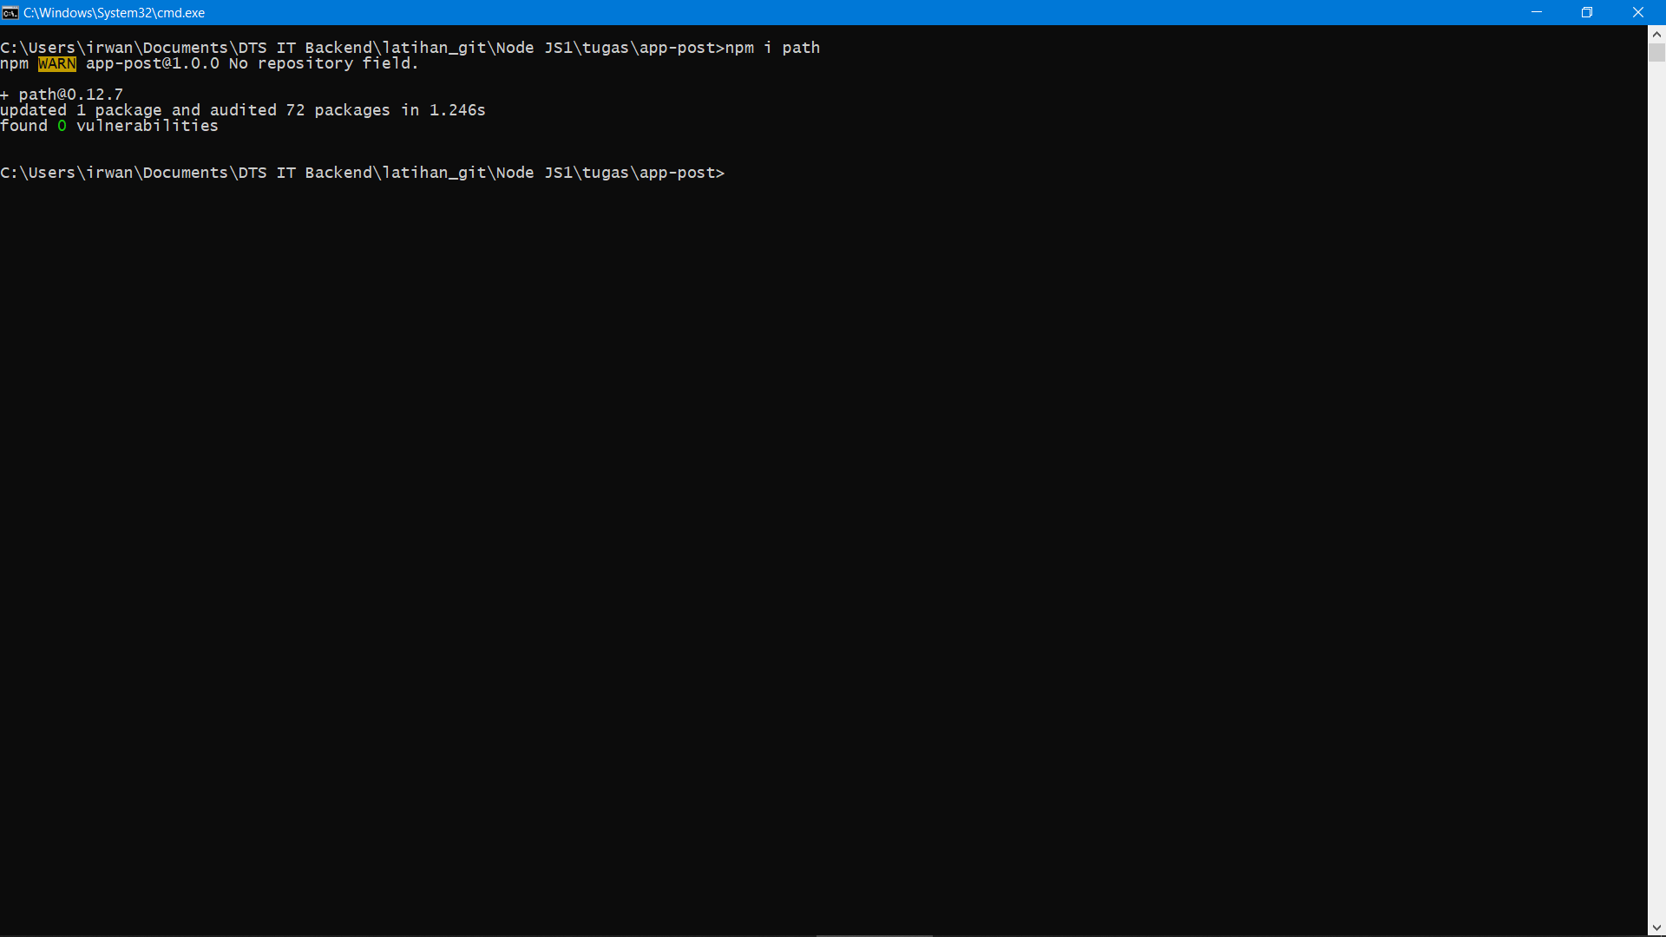

Install hbs framework : npm i hbs

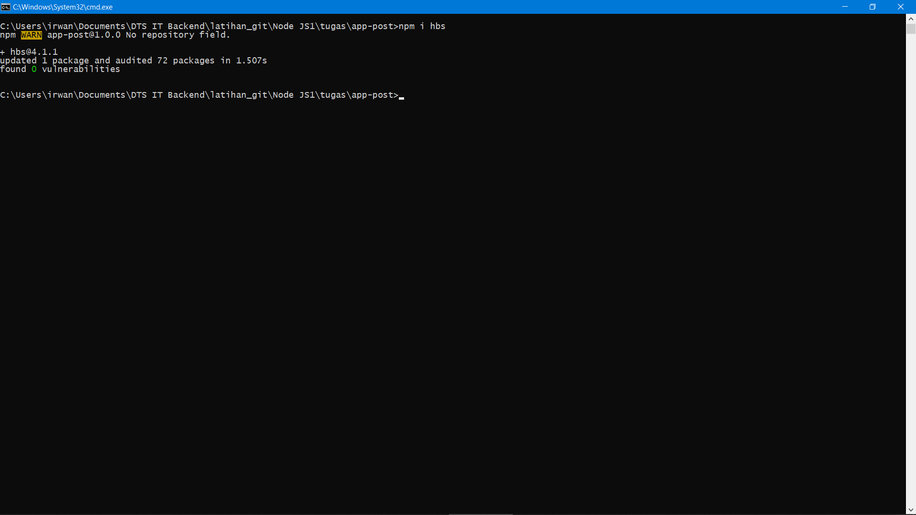

Install express framework : npm i express

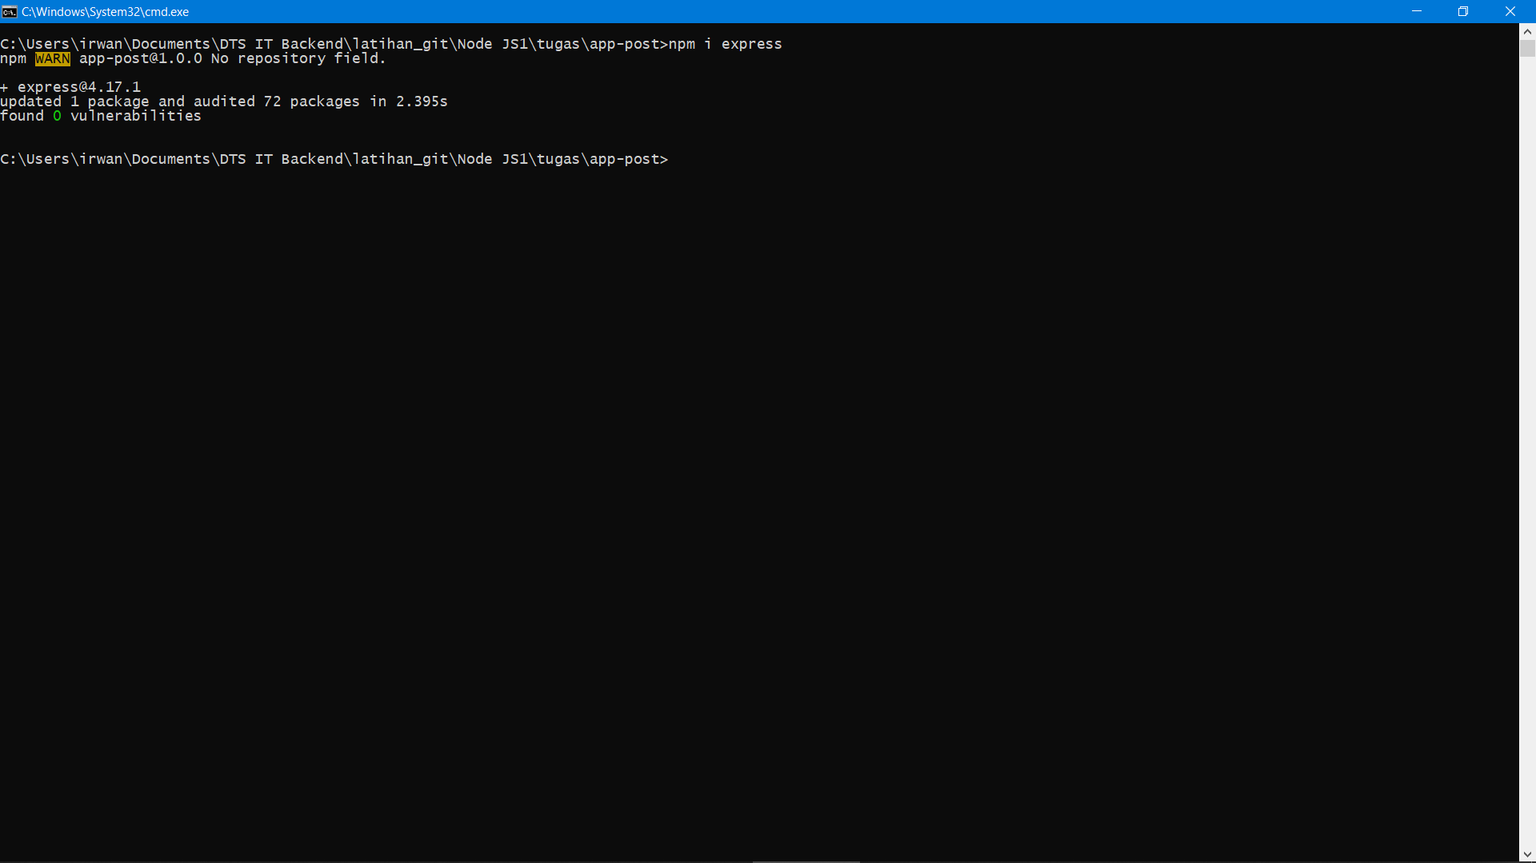

Install body parser framework: npm i body-parser

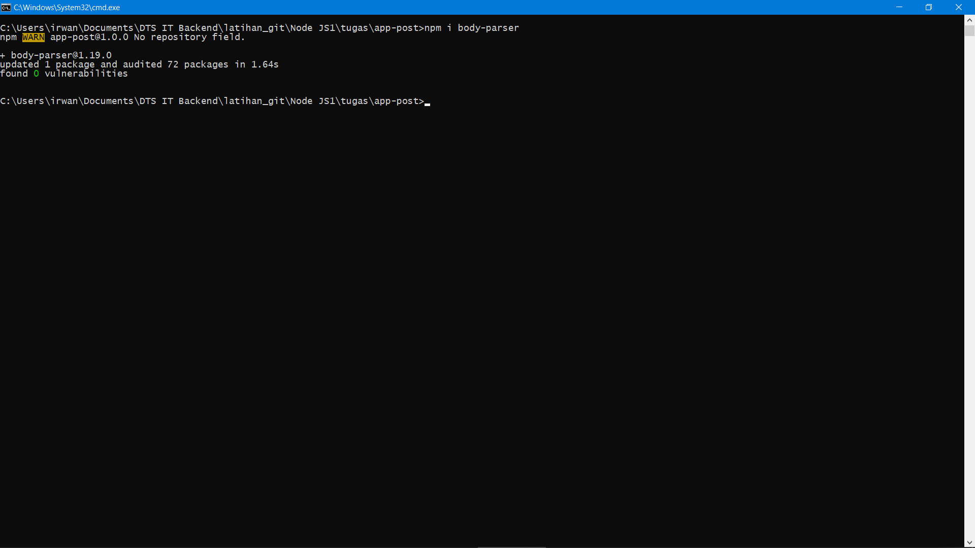

Execute :

Open directory file js.

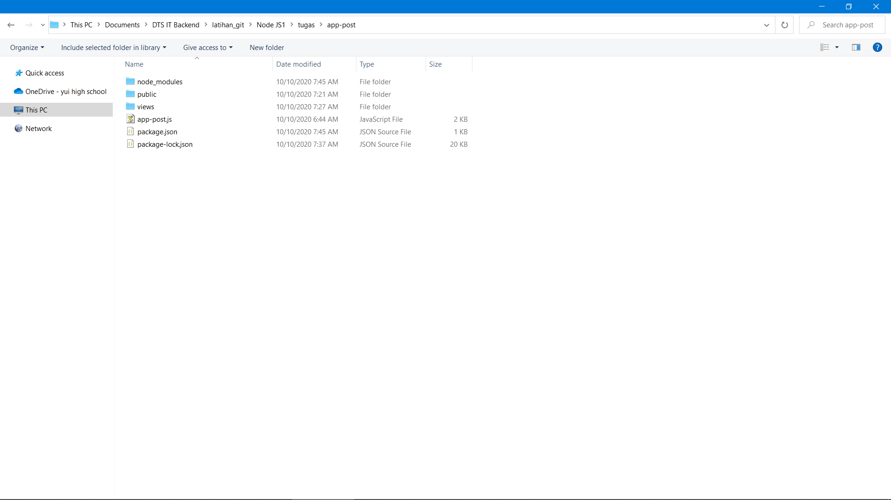

Change Address bar and type Cmd then press Enter

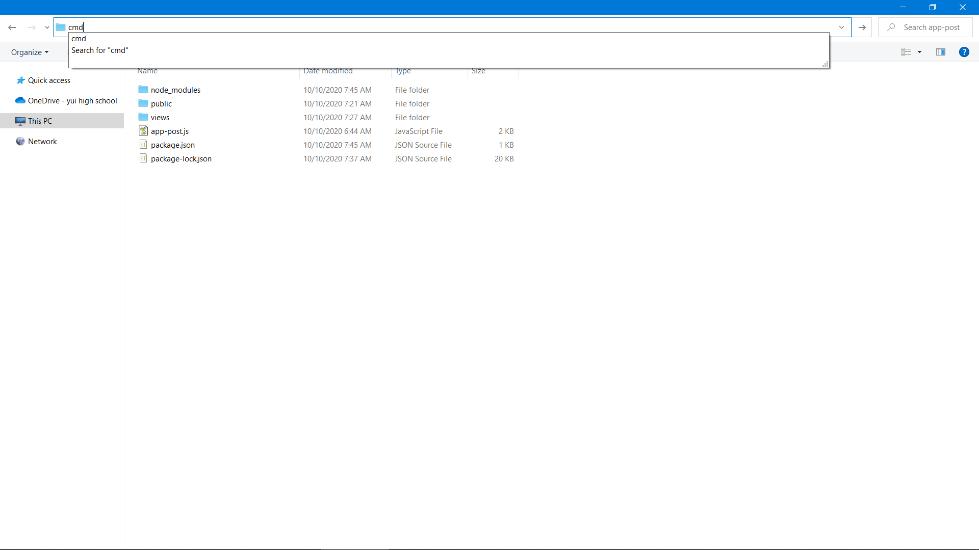

Command Line with the last path directory will shown.

Type “node app-post.js” in command line. Then press Enter and the web server will start on localhost:8000

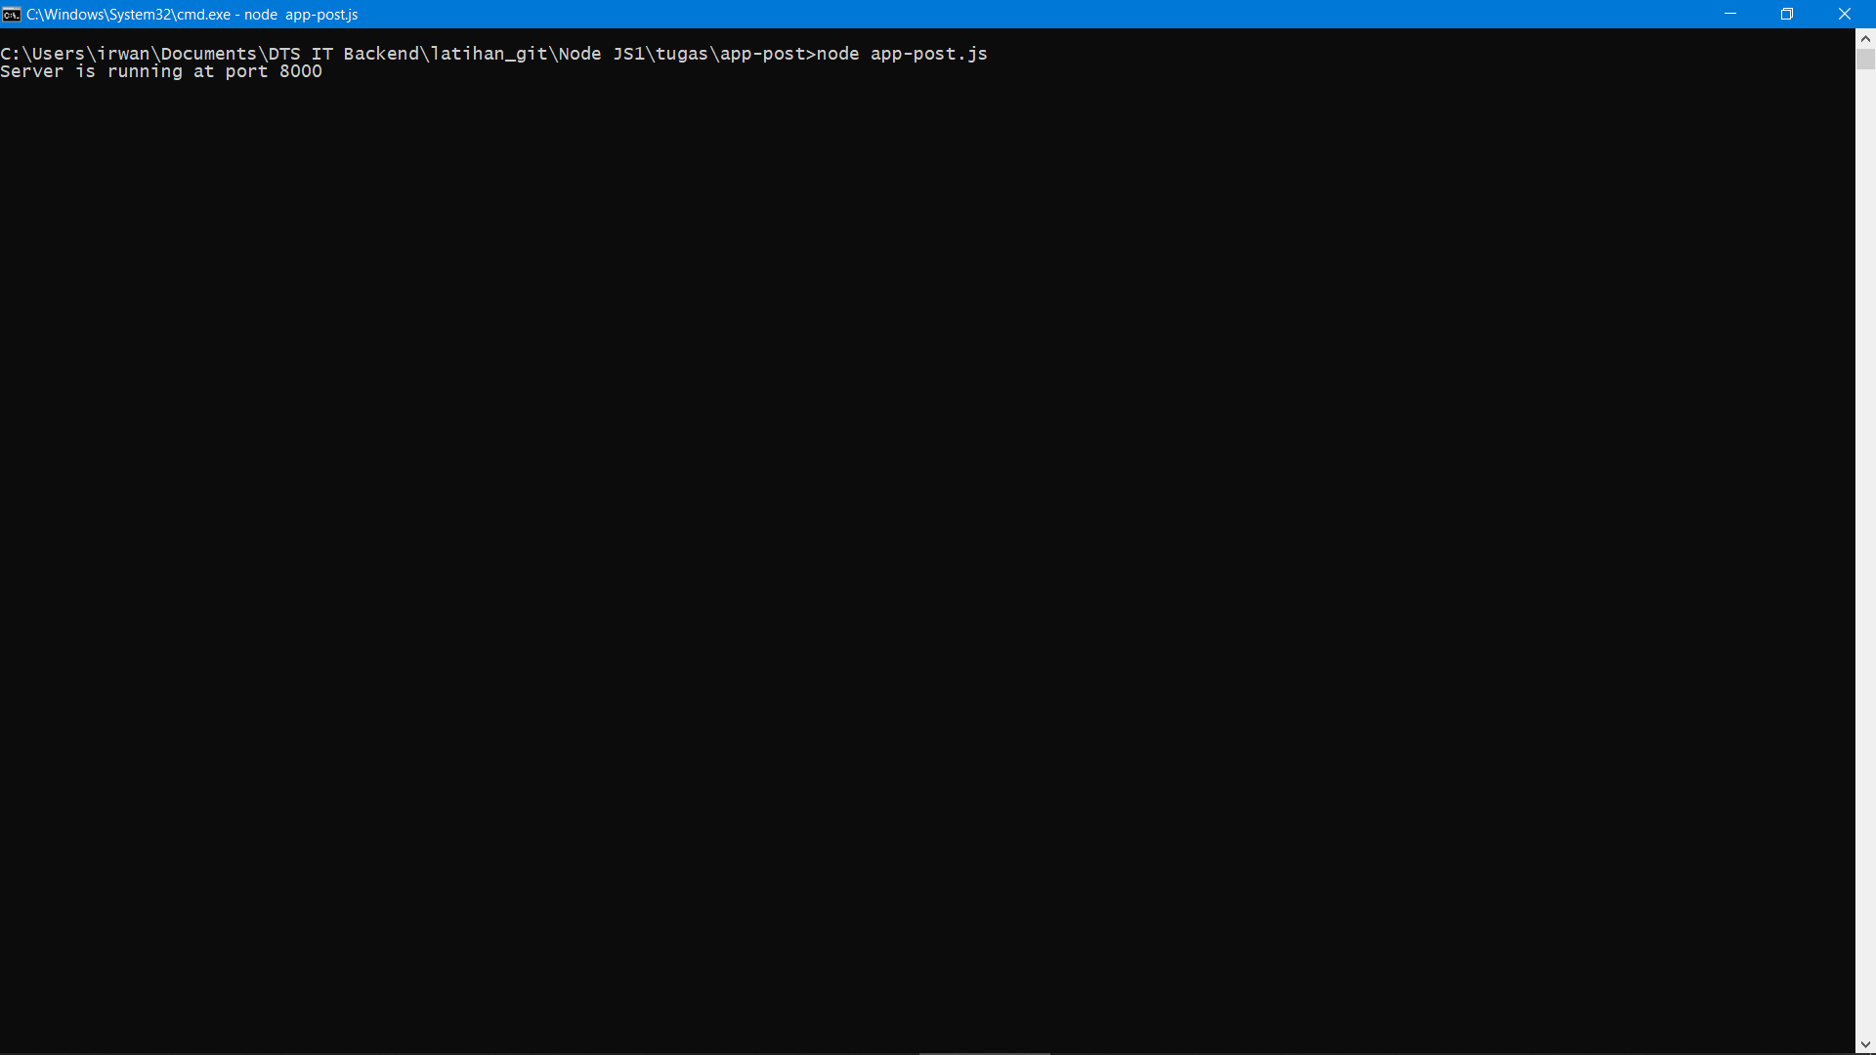

Output:

